Inferential Statistics
Inferential statistics is an important tool that allows us to make predictions and conclusions about a population based on sample data. Unlike descriptive statistics, which only summarize data, inferential statistics let us test hypotheses, make estimates, and measure the uncertainty about our predictions. These tools are essential for evaluating models, testing assumptions, and supporting data-driven decision-making.
For example, instead of surveying every voter in a country, we can survey a few thousand and still make reliable conclusions about the entire population’s opinion. Inferential statistics provides the tools to do this systematically and mathematically.

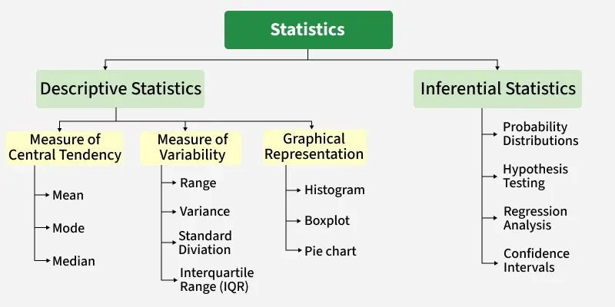
Techniques in Inferential Statistics
Inferential statistics offers several key methods for testing hypotheses, estimating population parameters, and making predictions. Here are the major techniques:
1. Confidence Intervals: It gives us a range of values that likely includes the true population parameter. It helps quantify the uncertainty of an estimate. The formula for calculating a confidence interval for the mean is:
CI = xˉ± Zα/2​ × ​σ /√n​
Where:
- xˉ is the sample mean
- ​Zα/2​ is the Z-value from the standard normal distribution (e.g., 1.96 for a 95% confidence interval)
- ​σ is the population standard deviation
- n is the sample size
2. Hypothesis Testing: Hypothesis testing is a formal procedure for testing claims or assumptions about data. It involves the following steps:
- Null Hypothesis (H₀): The default assumption, such as “there’s no difference between two models.”
- Alternative Hypothesis (H₁): The claim you aim to prove, such as “Model A performs better than Model B.”
We collect data and compute a test statistic (such as Z for a Z-test or t for a T-test):
$$z=\frac{x-μ_{0}}{\frac{σ}{\sqrt{n}}}$$Where:
- is the sample mean
- ​ is the hypothesised population mean
- is the population standard deviation
- is the sample size
After calculating the test statistic, we compare it with a critical value or use a p-value to decide whether to reject or accept the null hypothesis. If the p-value is smaller than the significance level α (usually 0.05), we reject the null hypothesis.
p-value=2⋅P(Z > ∣zobs​∣)
Where ​ is the observed test statistic, A small p-value suggests strong evidence against the null hypothesis.
3. Central Limit Theorem: It states that the distribution of the sample mean will approximate a normal distribution as the sample size increases, regardless of the original population distribution. This is important because many statistical methods assume that data is normally distributed. The CLT can be mathematically expressed as:
$$\tilde{X}\sim N\left(μ,\frac{σ}{\sqrt{n}}\right)$$
Where:
- is the population mean
- is the population standard deviation
- is the sample size
This theorem allows us to apply normal distribution-based methods even when the original data is not normally distributed, such as in cases with skewed income or shopping behavior data.
Errors in Inferential Statistics
In hypothesis testing, Type I Error and Type II Error are key concepts:
- Type I Error occurs when we wrongly reject a true null hypothesis. The probability of making a Type I error is denoted by (the significance level).
- Type II Error occurs when we fail to reject a false null hypothesis. The probability of making a Type II error is denoted by and the power of the test is given by .
The goal is to minimize these errors by carefully selecting sample sizes and significance levels.
Parametric and Non-Parametric Tests
Statistical tests help decide if the data support a hypothesis. They calculate a test statistic that shows how much the data differs from the assumption (null hypothesis). This is compared to a critical value or p-value to accept or reject the null.
- Parametric Tests: These tests assume that the data follows a specific distribution (often normal) and has consistent variance. They are typically used for continuous data. Examples include the Z-test, T-test, and ANOVA. These tests are effective for comparing models or measuring performance when the assumptions are met.
- Non-Parametric Tests: Non-parametric tests do not assume a specific distribution for the data, making them ideal for small samples or non-normal data, including categorical or ranked data. Examples include the Chi-Square test, Mann-Whitney U test, and Kruskal-Wallis test. They are useful when data is skewed or categorical, such as customer ratings or behaviors.
Example: Evaluating a New Delivery Algorithm Using Inferential Statistics
A quick commerce company wants to check if a new delivery algorithm reduces delivery times compared to the current system.
Experiment Setup:
- 100 orders split into two groups: 50 with the new algorithm, 50 with the current system.
- Delivery times for both groups are recorded.
Steps
1. Hypotheses:
- Null (H0): The New algorithm does not reduce delivery time.
- Alternative (H1): New algorithm reduces delivery time.
2. Significance Level:
Set at 0.05 (5% risk of wrongly rejecting H0).
- Type I error: Thinking the new system is better when it isn’t.
- Type II error: Missing a real improvement.
3. Test Statistic: Compare average delivery times between the two groups
4. Analysis:
- Calculate means and differences.
- Check if the data is roughly normal.
5. Perform a t-test or z-test:
If p-value < 0.05, reject H0 and conclude the new algorithm is better. Otherwise, no clear improvement.
6. Confidence Interval: For example, a range of -5 to -2 minutes means deliveries are 2 to 5 minutes faster with the new system.

